Question 1 Calc Assumed (13 marks)
The following table shows the calculation of the 3 point moving averages (y) used to smooth data
about number of plastic bags (given in millions) used at shopping centres in a large city.
Time Period (t) | Number of Plastic Bags | 3 point Moving Average ( 1 d.p.)
1. April 2012 | 4·8
2. August 2012 | 3·9 | 5·1
3. December 2012 | 6·6 | a
4. April 2013 | 4·2 | 4·9
5. August 2013 | 3·8 | 5.0
6. December 2013 | 7·0 | 4·8
7. April 2014 | 3·6 | 4·6
8. August 2014 | 3·2 | 4·3
9. December 2014 | b

(a) Fill in the missing entries labelled a and b in the boxes. (3 marks)
The average percentage method was used to calculate the values in the table below.
Time period | 1 | 2 | 3 | 4 | 5 | 6 | 7 | 8 | 9
Mean of the  cycle | 5.1 | 5.1 | 5.1 | 5.0 | 5.0 | 5.0 | 4.3 | 4.3 | 4.3
Number of  bags as a % | 94.1 | 76.5 | 129.4 | 84 | 76 | x | 83.7 | 74.4 | 141.9

(b) (i) Determine the value of x. (1 marks)
(ii) Use the values in the table to calculate the seasonal component for the
April season, correct to 2 decimal places. (2 marks)
A regression line was fitted to the 3 point moving averages given above.
It has equation:
y$^{^}$ = 5·34 – 0·1t
This equation was used to represent the trend of the time series.
The seasonal component for August is 0.756
(c) Use this equation, together with the seasonal component for August to predict the numbers
of plastic bags in August 2017. (3 marks)
(d) Determine the de−seasonalised value for August 2014. (2 marks)
(e) Explain with reference to the equation, which one quantity, more than any other, indicates the trend towards lower and lower numbers of plastic bags. (2 marks)

Solutions Question 1 Calc Assumed (13 marks)

(a) 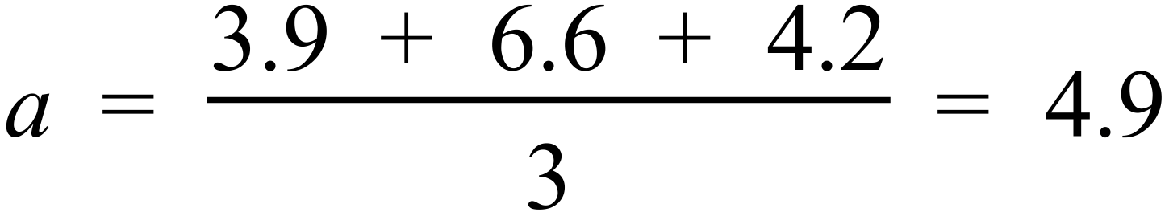
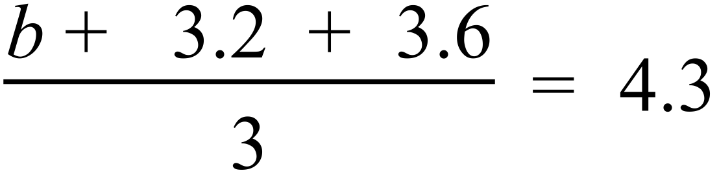
b = 6.1
(b) (i) x = 300 – ( 84 + 76 ) = 140 %
(ii) SC for April = 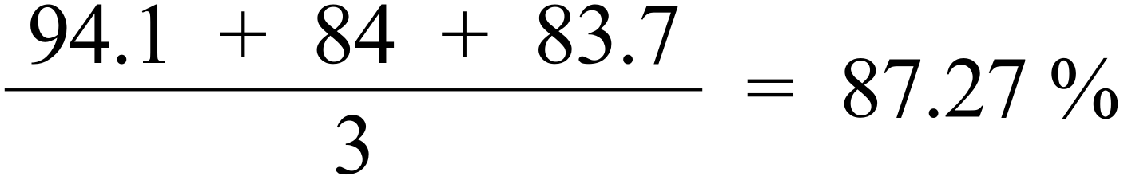
(c) t = 17
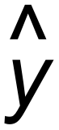 = 5.34 – 0.1t = 3.64
 3.64 million bags
(d) August 2014 has a value of 3.2
Deseasonalised value = 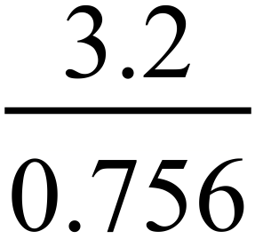 = 4.23 million
(e) Gradient = -0.1
Negative value indicates a decreasing trend. [13]

Question 2 Calc Free (7 marks)

Solutions Question 2 Calc Free (7 marks)

Question 3 Calc Assumed (16 marks)

Solutions Question 3 Calc Assumed (16 marks)

- Graph
- The underlying trend is upwards, so that the number of calls is increasing over the long term.
A weekly cycle with five seasons is evident, reflected in decreasing calls Mon to Weds and then increasing again to the next Mon.

- The number of calls on Weds is always the lowest for the week.

- $\frac{41+51+39+34+39}{5}=40.8$

- $A=44÷.96=45.8$

$$B=46÷1.04=44.2$$

- Using the table $D=0.5752T+37.3$
Using original data $D=0.5705T+37.3$

- On graph

- $T=16$
$$D=0.574×16+37.3=46.484$$
$$46.484×1.23=57.17$$
Expect 57 calls

